For immediate release Thursday 10th October 2019
Happy 1st Birthday to Little Saplings
Pendle Hill Landscape Partnership is celebrating its first year of their outdoor toddler group, Little Saplings. The Forest School inspired events launched in September 2018, in the first year of the Pendle Hill project. Since last September, 780 children participants have attended 42 sessions, accompanied by 648 adults.
The toddler group, which is fully funded by the National Lottery Heritage Fund and in partnership with the Ernest Cook Trust, has invited under five year olds to attend the bi-monthly Wednesday events at local nature sites within Pendle and the Ribble Valley. Regular parents describe Little Saplings as "A wonderful, well supported, interactive session for children to learn and explore the outdoors".
The free Little Saplings sessions are aimed at pre-school children. They currently occur at Spring Wood, Whalley in the morning and at Victoria Park, Nelson in the afternoon, on the 2nd and 4th Wednesdays of each month. There is a different theme per session, with recent themes being Stick Man, Ladybird, weather and hedgehogs. The children also enjoy mud kitchen, nature trails and minibeast hunting.
The sessions are child led, with a focus on upskilling the little ones, particularly in resilience, confidence and self-esteem in a woodland. Outdoor Learning Officer Alison, who is funded though The Ernest cook Trust, said, “It has been wonderful to watch Little Sapling participants grow in confidence of being in a woodland setting and knowledge of nature. Parents have also improved their nature identification skills, discovered mini activities they can play with their toddler and learnt how to look after the wildlife on their doorstep. I hope this knowledge is something they can share with other families, to help make the Pendle Hill community more nature aware."
Claire, mum of three said: “The kids had a ball and been full of stories about it all afternoon, we've booked on next Wednesday, so see you then." October, November and December theme sessions are Natural Art, the Gruffalo and winter festivities.
Families can now book their 18 months to five year olds onto the 2019 sessions via the Pendle Hill Landscape Partnership website (https://pendlehillproject.com/little-saplings). Further details about times and locations available on the website.

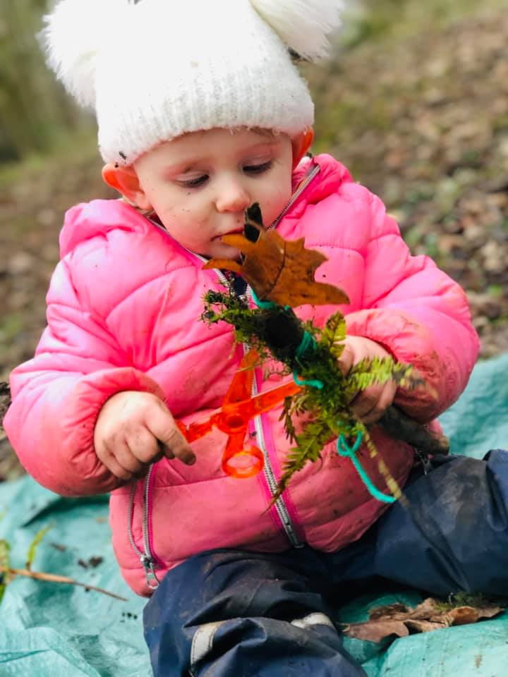

Little one making nature stick.

Mud kitchen fun
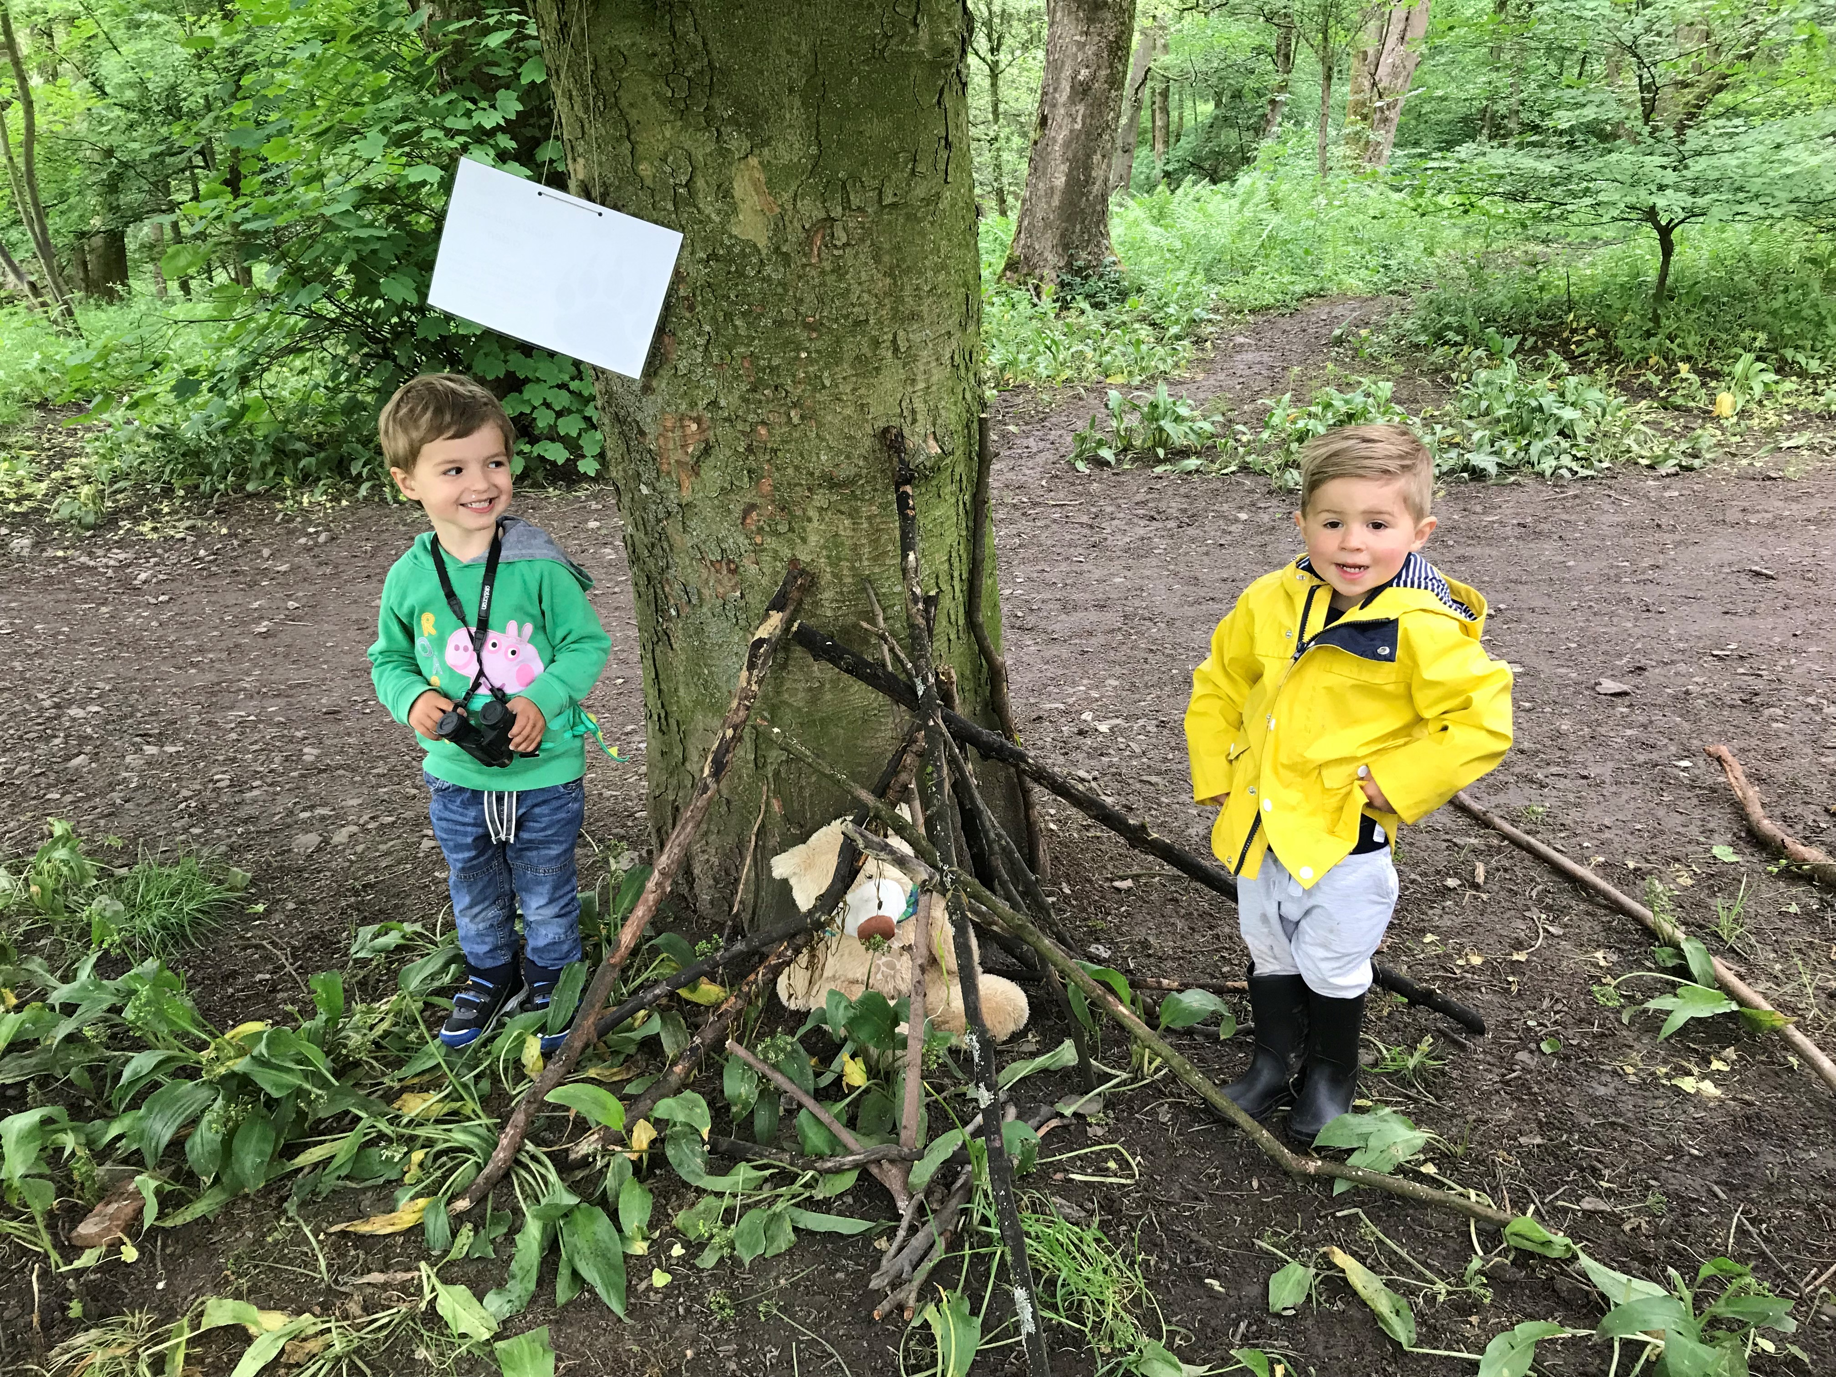
Building a den for teddy bear

EDITORS NOTES
- The Pendle Hill landscape partnership is led by the Forest of Bowland AONB.
- The partnership aims to:
I. restore, enhance and conserve the heritage and landscape of Pendle Hill
II. reconnect people with their past and their landscape
III. bring the two sides of the hill together
IV. create a sustainable future for the environment, heritage and for visitors' experience of Pendle Hill
- The scheme was awarded a National Lottery grant of £1.8million by the Heritage Lottery Fund in January 2018. These funds will be delivered from 2018-2022 and will be matched with a further £1m raised locally.
- The scheme is made up of a dozen projects which safeguard the area's wildlife and heritage and improve people's access to this popular countryside area. We will do this by providing opportunities for training and volunteering; by supporting research and devising creative and digital interpretation to inspire a new generation about our heritage; by restoring important landscape features, and by working with communities to re-tell the stories of radical Pendle people. The scheme will increase pride in this special place and raise aspirations amongst communities, and it will bring in new investment to support the environment and the economy.
- The Pendle Hill landscape partnership is supported by National Lottery players through the Heritage Lottery Fund and by the Forest of Bowland AONB. Partners include representatives of parish councils, the landowning and farming community, Pendle and Ribble Valley Borough Councils, Lancashire County Council, statutory bodies, tourism businesses and volunteers.
- Projects will be delivered by the AONB team, plus local delivery partners including In –Situ Arts, the Dry Stone Walling Association, Mid Pennine Arts and Ribble Rivers Trust.
- The Pendle Hill LP covers 120 square kilometres, stretching from Gisburn down to Whalley, and from Clitheroe across to Nelson and Padiham.
- The Hill is well known as a beauty spot and is heavily visited by residents of the local towns: it is a perfect place for walking and cycling. The area's heritage is dominated by the story of the Pendle Witches, but there are lots more stories to tell including the founding of the Quaker movement, non- conformists and radicals, Roman and Bronze Age settlers, medieval farming systems and early industrial developments. The network of dry stone walls and hedgerows give the area a distinctive feel, and the landscape is also important for its wild moorland, rare birds and woodlands.
- For further information contact the LP Scheme Manager cathy.hopley@lancashire.gov.uk on 07891 537835 / 01200 420420
- Visit the project website at www.pendlehillproject.com or visit our Facebook page 'Pendle Hill Project' for up to date news and views.
About the Heritage Lottery Fund
Thanks to National Lottery players, we invest money to help people across the UK explore, enjoy and protect the heritage they care about - from the archaeology under our feet to the historic parks and buildings we love, from precious memories and collections to rare wildlife. www.hlf.org.uk Follow us on Twitter, Facebook and Instagram and use #HLFsupported

About The Ernest Cook Trust
The Outdoor Learning project is led by the Outdoor Learning Officer, who is employed through the Ernest Cook Trust. ECT was founded as an educational trust by Ernest Cook, grandson of Thomas Cook (the travel agent), in 1952. ECT's vision is inspiring young people to achieve better education and life outcomes by learning from the land. In order to increase this reach they have begun to partner with a range of organisations in different parts of the UK, hence their involvement with the Pendle Hill Landscape Partnership. The Outdoor Learning Officer will provide a key role in broadening learning aspects of the PHLP, providing additional family activities and formal education methods to engage with the PHLP community

