MEET YOU AT THE TOP!
More than 200 people march to the summit to celebrate the outstanding beauty of the Pendle Landscape

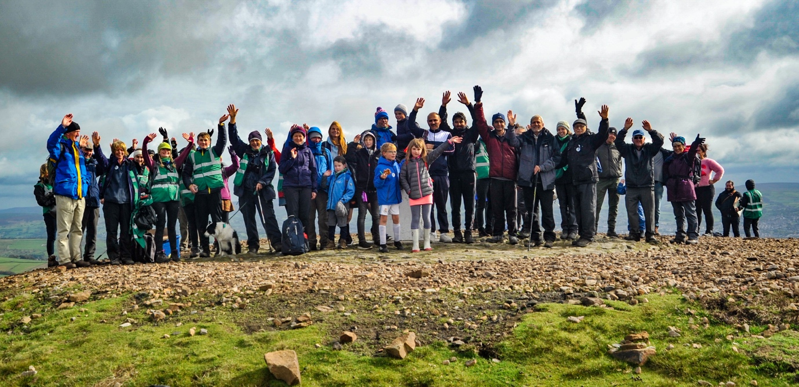

MORE than 200 people from both sides of Pendle joined the mayors and mayoresses of Ribble Valley and Pendle in a mass march to the summit of our iconic hill.

The rain held off and the sun came out just as the walkers hit the summit plateau – illuminating the brilliant white trig point like a beacon and bathing the surrounding countryside in beautifully soft autumn light.

Children, mums, dads, grand-parents and some very happy dogs set out from either Barley or Downham and completed their expeditions and gathered for an impromptu picnic and some inspiring poetry from local poets Andrew Collinson and Michael Neary.

Organised to celebrate the launch of the Pendle Hill Landscape Partnership – a Heritage Lottery Funded programme, with aims to restore, enhance and conserve the heritage and landscape of Pendle Hill, while reconnecting people with their past and providing a sustainable future for the environment. The walk promoted the projects aim of bringing both sides of the hill together. The event was extensively promoted via social media using the #MeetYouAtTheTop hashtag.

With members of Mountain Rescue standing by, Pendle Hill Landscape Partnership Volunteers marshalled both routes to ensure people found their way safely to the top – and found out more about the project.

Participants collected their ticket to the trig trail and map from members the Landscape Partnership team, to discover more about our hill on route and children were encouraged to find trail answers painted on pebbles, hidden within the landscape.
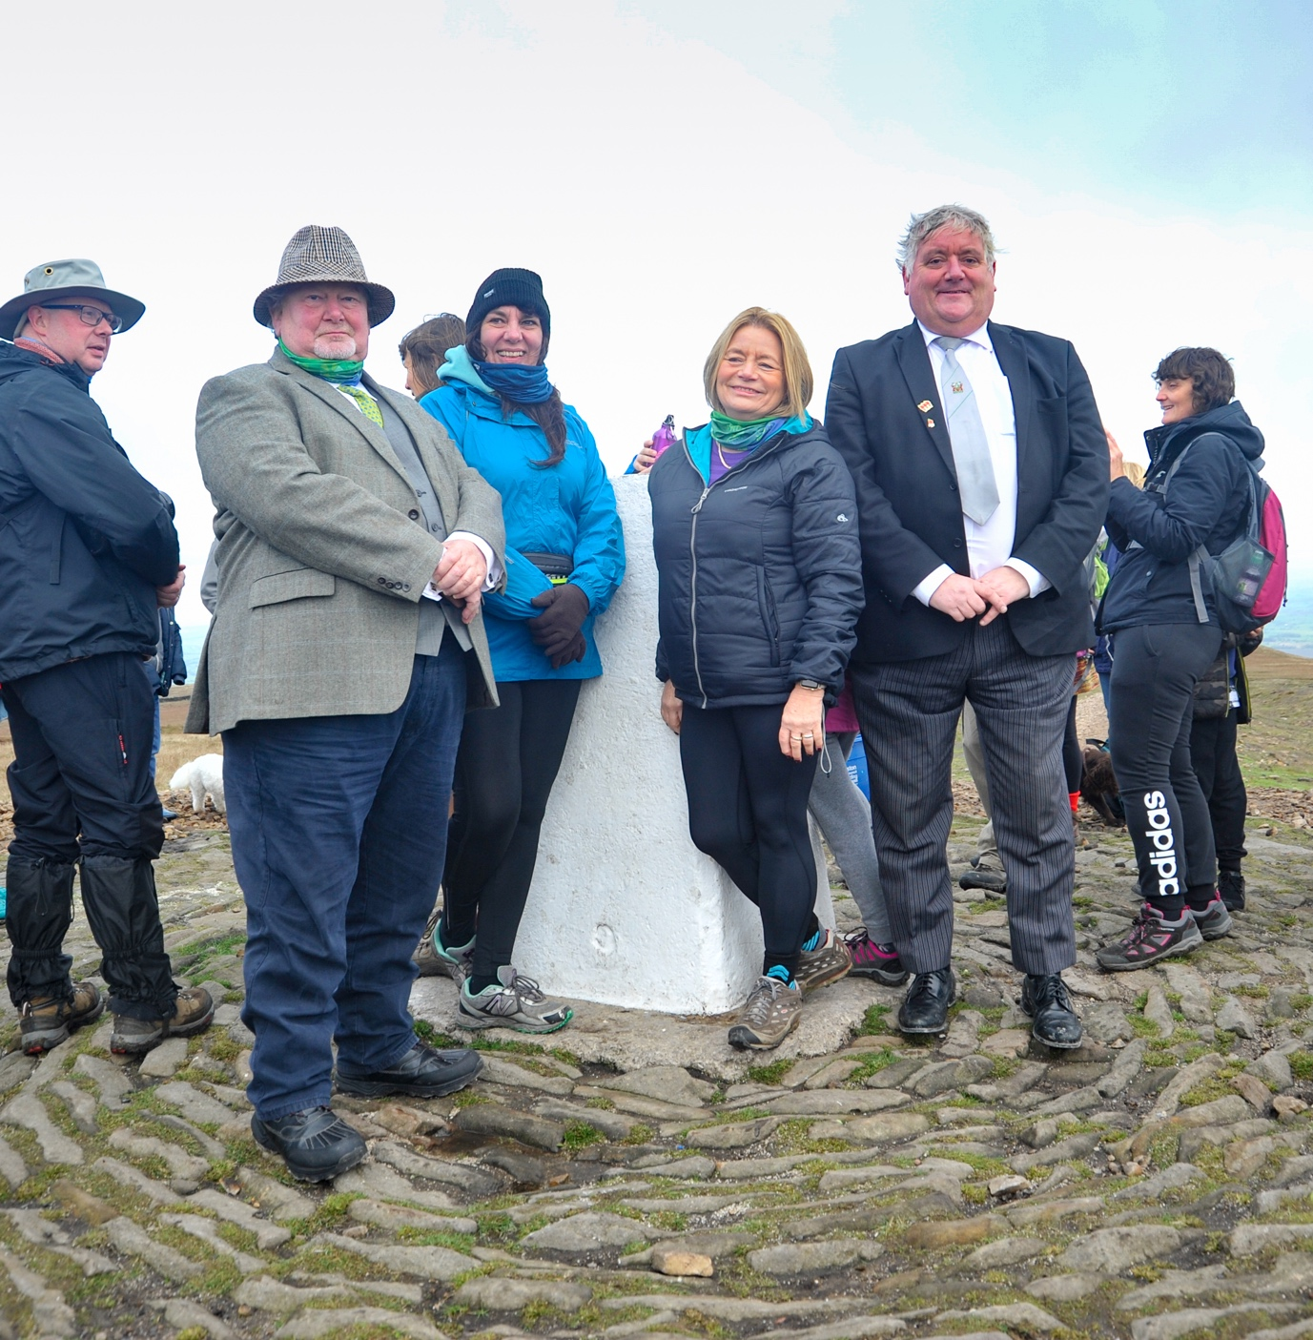

Caption: Pendle Mayor and Mayoress James Starkie and Janet Starkie at the Pendle summit trig point with Ribble Valley Mayor and Mayoress Stuart Carefoot and Sarah Rainford.

Young hikers who successfully completed the trail sheet received a #MeetYouAtTheTop water bottle, pen and PHLP sticker. On the summit, there were #SummitSelfies, group photos, drone filming and picnics at the newly refurbished shelter – one of the first of the Landscape projects to be completed.

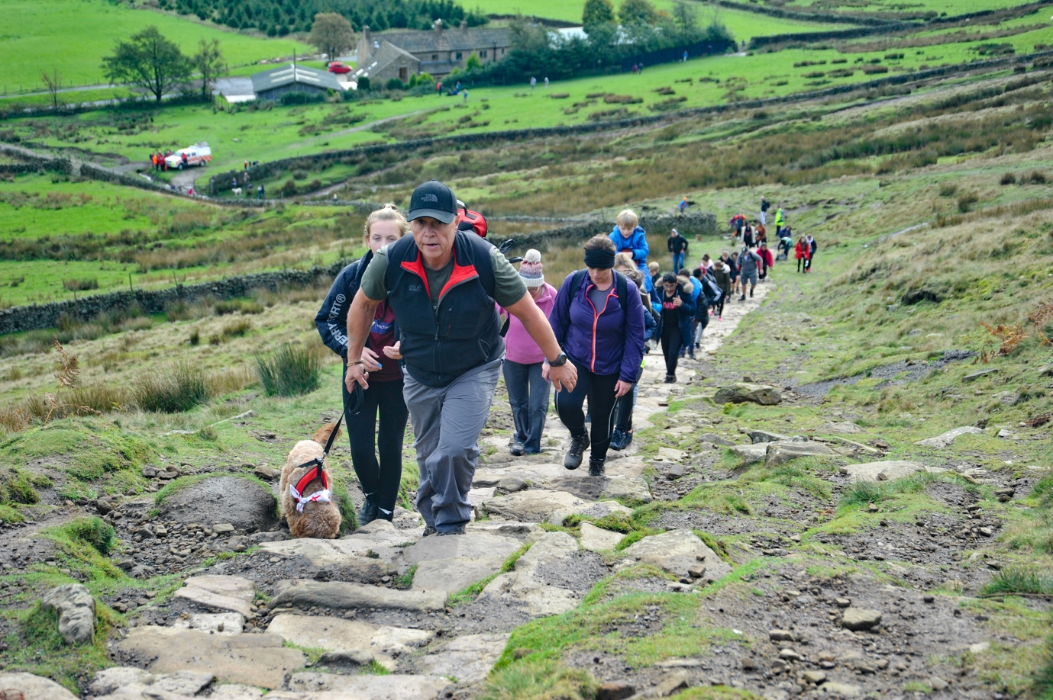

Pendle Hill Landscape Partnership project manager Cathy Hopley said: “We were delighted to see so many people make the effort to meet us at the top. There was a wonderfully friendly atmosphere at the trig point and it was really encouraging to see so much interest in the project from people of so many different ages from both sides of the hill.

“One of the main aims of the Landscape Partnership is to bring people together to celebrate this outstandingly beautiful landscape and share their enjoyment of it with others – both from the local community and further afield.

“We have an ambitious programme of events – starting with our Foodie Foray next week and our hard-working volunteers and supporters are working hard to make sure they are as enjoyable and informative as this wonderful event.”

Thanks to the following groups and organisations who made it a super successful event:

In-Situ
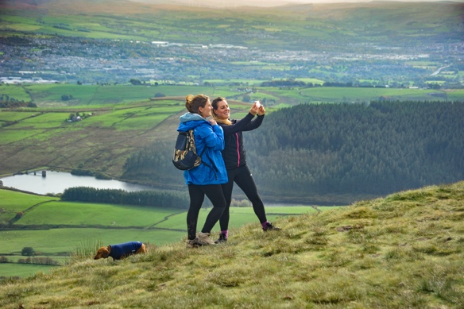
Pendle Hill Landscape Partnership Volunteers
Lancashire County Council Volunteers
Rossendale & Pendle Mountain Rescue Team
Ribble Valley Borough Council Mayor and Mayoress
Pendle Council Mayor and Mayoress
People Enjoying Nature participants (for painting all the pebble answers)
Pendle Hill HLF Project team
Forest of Bowland AONB team
Lancashire Police Cadets
Conservefor Limited

NOTES TO EDITORS

- The Pendle Hill landscape partnership is led by the Forest of Bowland AONB.
- The partnership aims to:
I. restore, enhance and conserve the heritage and landscape of Pendle Hill
II. reconnect people with their past and their landscape
III. bring the two sides of the hill together
IV. create a sustainable future for the environment, heritage and for visitors' experience of Pendle Hill

- The scheme was awarded a National Lottery grant of £1.8million by the Heritage Lottery Fund in January 2018. These funds will be delivered from 2018-2022 and will be matched with a further £1m raised locally.
- The scheme is made up of a dozen projects which safeguard the area's wildlife and heritage and improve people's access to this popular countryside area. We will do this by providing opportunities for training and volunteering; by supporting research and devising creative and digital interpretation to inspire a new generation about our heritage; by restoring important landscape features, and by working with communities to re-tell the stories of radical Pendle people. The scheme will increase pride in this special place and raise aspirations amongst communities, and it will bring in new investment to support the environment and the economy.
- The Pendle Hill landscape partnership is supported by National Lottery players through the Heritage Lottery Fund and by the Forest of Bowland AONB. Partners include representatives of parish councils, the landowning and farming community, Pendle and Ribble Valley Borough Councils, Lancashire County Council, statutory bodies, tourism businesses and volunteers.
- Projects will be delivered by the AONB team, plus local delivery partners including In –Situ Arts, the Dry Stone Walling Association, Mid Pennine Arts and Ribble Rivers Trust.
- The Pendle Hill LP covers 120 square kilometres, stretching from Gisburn down to Whalley, and from Clitheroe across to Nelson and Padiham.
- The Hill is well known as a beauty spot and is heavily visited by residents of the local towns: it is a perfect place for walking and cycling. The area's heritage is dominated by the story of the Pendle Witches, but there are lots more stories to tell including the founding of the Quaker movement, non- conformists and radicals, Roman and Bronze Age settlers, medieval farming systems and early industrial developments. The network of dry stone walls and hedgerows give the area a distinctive feel, and the landscape is also important for its wild moorland, rare birds and woodlands.
- For further information contact the LP Scheme Manager cathy.hopley@lancashire.gov.uk on 07891 537835 / 01200 420420
- Visit the project website at www.pendlehillproject.com or visit our Facebook page 'Pendle Hill Project' for up to date news and views.

About the Heritage Lottery Fund
Thanks to National Lottery players, we invest money to help people across the UK explore, enjoy and protect the heritage they care about - from the archaeology under our feet to the historic parks and buildings we love, from precious memories and collections to rare wildlife. www.hlf.org.uk Follow us on Twitter, Facebook and Instagram and use #HLFsupported

