PRESS RELEASE
HAPPY 1ST BIRTHDAY TO THE PENDLE HILL LANDSCAPE PARTNERSHIP!
10th May 2019
It's been a busy first year for the Pendle Hill Landscape Partnership. Most of the 14 projects are now up and running and are making a positive impact on the landscape and heritage of the area. The illustration shows some of the key achievements since last summer.

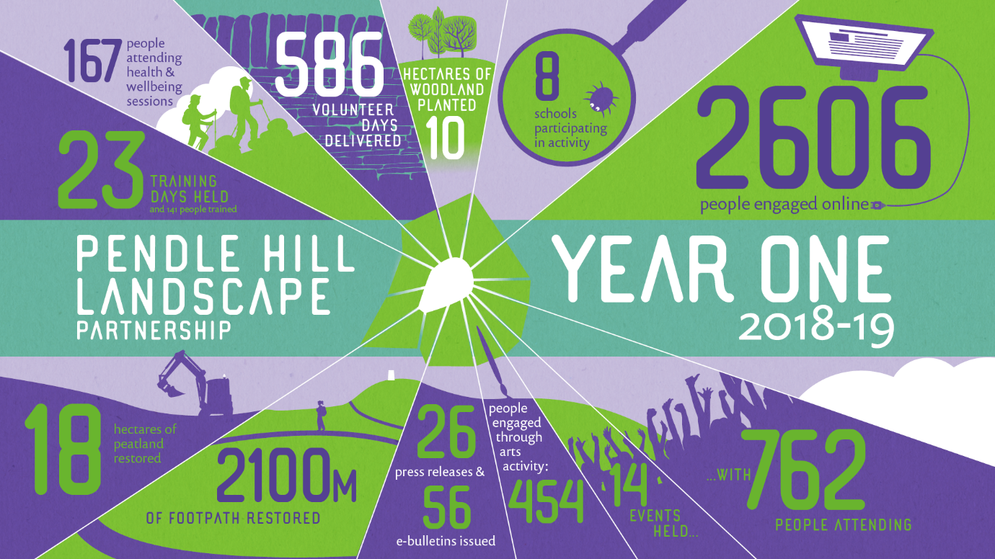
The work will continue for a further three years, and the team are looking forward to running many more new activities, community events and opportunities to learn more about Pendle Hill's fantastic landscape and local heritage.
Highlights for year 2 include:
- the unveiling of the Pendle Mobile Hut on Saturday 25th May at the Garage in Brierfield as part of an annual Gathering event
- installation of the Pendle Radicals Trail celebrating notable thinkers and activists from the area
- production of village Treasure Trail leaflets in Barrowford and Sabden
- creation of a new bridleway linking Chatburn with Downham; and the refurbishment of the Information Barn in Downham
- a programme of free outdoor learning events for schools and toddlers, and also for families during half term and the summer holidays
- continuing opportunities for volunteering through our programme of regular practical conservation days; plus activities for People Enjoying Nature which is our project supporting people dealing with mental health and social isolation issues
- another chance to apply for funds for community heritage schemes in the LP area
- free training in dry stone walling and hedgelaying skills; plus a number of walls and hedges will be restored to good condition
The annual Gathering event, which will showcase much of this work and how to get involved is to be held in Brierfield on Saturday 25th May.
This is your chance to find out more about what the Pendle Hill project has been up to so far, and what opportunities there are to get involved now and over the next 3 years.
Hosted at In-Situ's new base at the Garage (next to the Leisure box at Northlight) the Gathering will take place between 12.00 noon and 3.00pm and there will be opportunity to meet some of the staff and volunteers involved.
There will be exhibitions and displays; live music, film and performances; family activities; refreshments (including the amazing Pendle Pie and Peat Pud!); and the unveiling of the Pendle Mobile Hut.
The Mobile Hut is In-Situ's latest commission for the landscape partnership. Designed and built by Nick Wood of How About Studio (https://howaboutstudio.com/ ) this beautifully designed and crafted 'hut on a trailer' will become a mobile base for the project and will act as a studio for artists and an information cabin. The team hope it will bring Pendle Hill to the towns and villages, and enable even more people to enjoy and learn about our fabulous landscape and heritage.
ENDS

EDITORS NOTES
- The Pendle Hill landscape partnership is led by the Forest of Bowland AONB.
- The partnership aims to:
I. restore, enhance and conserve the heritage and landscape of Pendle Hill
II. reconnect people with their past and their landscape
III. bring the two sides of the hill together
IV. create a sustainable future for the environment, heritage and for visitors' experience of Pendle Hill
- The scheme was awarded a National Lottery grant of £1.8million by the National Lottery Heritage Fund in January 2018. These funds will be delivered from 2018-2022 and will be matched with a further £1m raised locally.
- The scheme is made up of a dozen projects which safeguard the area's wildlife and heritage and improve people's access to this popular countryside area. We will do this by providing opportunities for training and volunteering; by supporting research and devising creative and digital interpretation to inspire a new generation about our heritage; by restoring important landscape features, and by working with communities to re-tell the stories of radical Pendle people. The scheme will increase pride in this special place and raise aspirations amongst communities, and it will bring in new investment to support the environment and the economy.
- The Pendle Hill landscape partnership is supported by National Lottery players through the Heritage Fund and by the Forest of Bowland AONB. Partners include representatives of parish councils, the landowning and farming community, Pendle and Ribble Valley Borough Councils, Lancashire County Council, statutory bodies, tourism businesses and volunteers.
- Projects will be delivered by the AONB team, plus local delivery partners including In –Situ Arts, the Dry Stone Walling Association, Mid Pennine Arts and Ribble Rivers Trust.
- The Pendle Hill LP covers 120 square kilometres, stretching from Gisburn down to Whalley, and from Clitheroe across to Nelson and Padiham.
- The Hill is well known as a beauty spot and is heavily visited by residents of the local towns: it is a perfect place for walking and cycling. The area's heritage is dominated by the story of the Pendle Witches, but there are lots more stories to tell including the founding of the Quaker movement, non- conformists and radicals, Roman and Bronze Age settlers, medieval farming systems and early industrial developments. The network of dry stone walls and hedgerows give the area a distinctive feel, and the landscape is also important for its wild moorland, rare birds and woodlands.
- For further information contact the LP Scheme Manager cathy.hopley@lancashire.gov.uk on 07891 537835 / 01200 420420
- Visit the project website at www.pendlehillproject.com or visit our Facebook page 'Pendle Hill Project' for up to date news and views.
About the Heritage Fund
Thanks to National Lottery players, we invest money to help people across the UK explore, enjoy and protect the heritage they care about - from the archaeology under our feet to the historic parks and buildings we love, from precious memories and collections to rare wildlife. www.hlf.org.uk Follow us on Twitter, Facebook and Instagram and use #HLFsupported

