PRESS RELEASE
Monday 12th April 2021
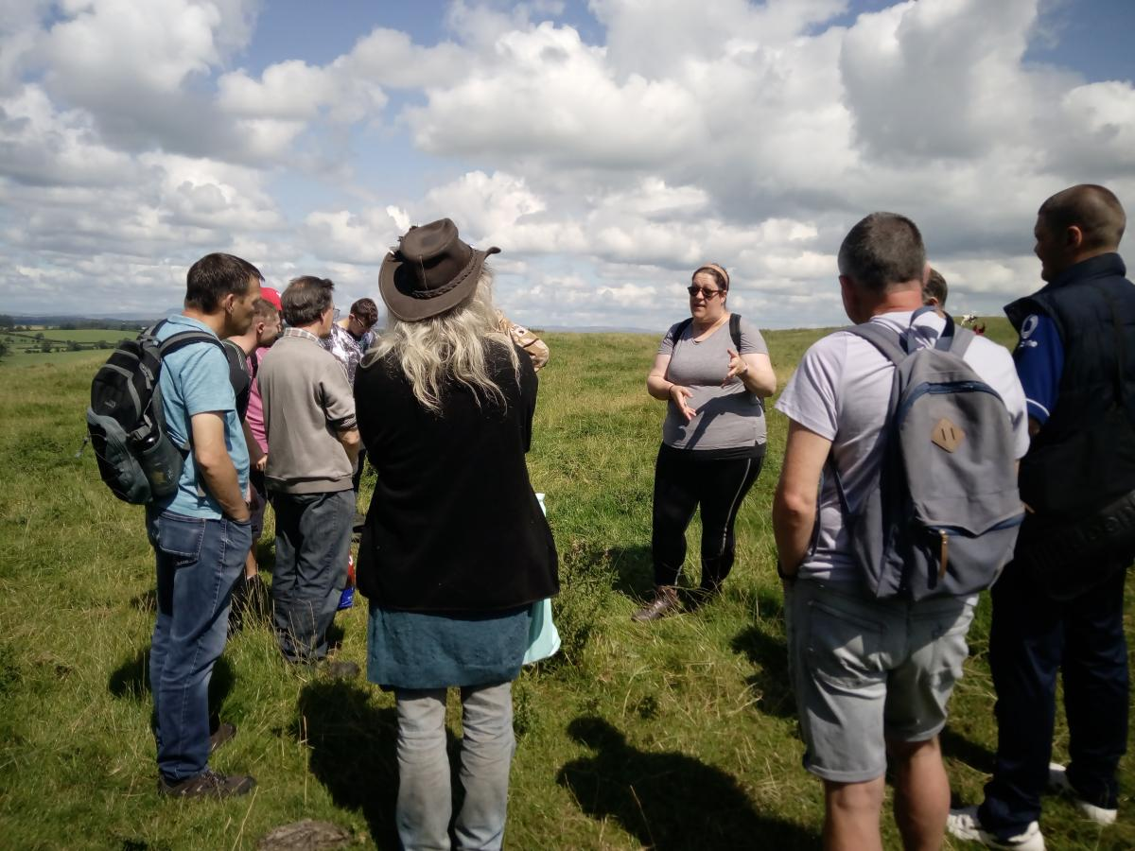

'Pendle Hill In The Past'
The Pendle Hill Landscape Partnership will once again be running a series of online events for you to get involved with. This time, you are invited to find out more about past archaeological and historical research in the area.
Postponed from last March, and following on from a year of successful online events, The Pendle Hill Landscape Partnership have now decided to take it's Community Archaeology Forum online, having received a fantastic amount of support from local archaeologists and historians.
The first event will be held on Monday 26th April at 6.30pm, when you can hear all about the Pendle Hill Landscape Partnership's Community Archaeology project, and past discoveries across the area, from Community Engagement Officer Jayne Ashe. Brian Jeffery, on behalf of the Pendle Forest History Group, will then talk about the industrial heritage of Roughlee, and the research the group has been doing with the support of Roughlee Parish Council.
On Tuesday 4th May at 6.30pm, you can listen in to Dr David Johnson as he tells us more about Chatburn to Downham: 300 years of Lime Burning.
The penultimate event will be held on Saturday 8th May at 6.30pm. This will feature Danielle Knights, a student from UCLan, who will give an insight into her experiences delivering archaeology activities to community groups and members of the public. Finds Liaison Officer, Alex Whitlock, will then tell us more about Lancashire's Portable Antiquities Service and how they have been operating through the Covid pandemic.
Finally, on Wednesday 12th May at 6.30pm, join us to learn more about recent discoveries of a Bronze Age ring ditch near Clitheroe from David Cockcroft, who works for Archaeological Research Services.
Everyone is welcome, no matter how much you already know about archaeology, but booking is essential Each event will last for around 90 minutes and you can book onto 1, 2, 3 or all the live events. Simply book your place via the Pendle Hill Landscape Partnerships Website or contact Jayne Ashe at the Pendle Hill Landscape Partnership on jayne.ashe@lancashire.gov.uk

NOTES FOR EDITORS
For more information please email nichola.gill@lancashire.gov.uk or jayne.ashe@lancashire.gov.uk
Images show:
Danielle Knights delivering community archaeology within the Landscape Partnership. © Pendle Hill Landscape Partnership

- The Pendle Hill landscape partnership is led by the Forest of Bowland AONB.
- The partnership aims to:
I. restore, enhance and conserve the heritage and landscape of Pendle Hill
II. reconnect people with their past and their landscape
III. bring the two sides of the hill together
IV. create a sustainable future for the environment, heritage and for visitors' experience of Pendle Hill
- The scheme was awarded a National Lottery grant of £1.8million by the National Lottery Heritage Fund in January 2018. These funds will be delivered from 2018-2022 and will be matched with a further £1m raised locally.
- The scheme is made up of a dozen projects which safeguard the area's wildlife and heritage and improve people's access to this popular countryside area. We will do this by providing opportunities for training and volunteering; by supporting research and devising creative and digital interpretation to inspire a new generation about our heritage; by restoring important landscape features, and by working with communities to re-tell the stories of radical Pendle people. The scheme will increase pride in this special place and raise aspirations amongst communities, and it will bring in new investment to support the environment and the economy.
- The Pendle Hill landscape partnership is supported by National Lottery players through the Heritage Fund and by the Forest of Bowland AONB. Partners include representatives of parish councils, the landowning and farming community, Pendle and Ribble Valley Borough Councils, Lancashire County Council, statutory bodies, tourism businesses and volunteers.
- Projects will be delivered by the AONB team, plus local delivery partners including In –Situ Arts, the Dry Stone Walling Association, Mid Pennine Arts and Ribble Rivers Trust.
- The Pendle Hill LP covers 120 square kilometres, stretching from Gisburn down to Whalley, and from Clitheroe across to Nelson and Padiham.
- The Hill is well known as a beauty spot and is heavily visited by residents of the local towns: it is a perfect place for walking and cycling. The area's heritage is dominated by the story of the Pendle Witches, but there are lots more stories to tell including the founding of the Quaker movement, non- conformists and radicals, Roman and Bronze Age settlers, medieval farming systems and early industrial developments. The network of dry stone walls and hedgerows give the area a distinctive feel, and the landscape is also important for its wild moorland, rare birds and woodlands.
- For further information contact the LP Scheme Manager cathy.hopley@lancashire.gov.uk on 07891 537835 / 01200 420420
- Visit the project website at www.pendlehillproject.com or visit our Facebook page 'Pendle Hill Project' for up to date news and views.

About the National Lottery Heritage Fund
Using money raised by the National Lottery, we Inspire, lead and resource the UK's heritage to create positive and lasting change for people and communities, now and in the future. www.heritagefund.org.uk
Follow @HeritageFundUK on Twitter, Facebook and Instagram and use #NationalLotteryHeritageFund

