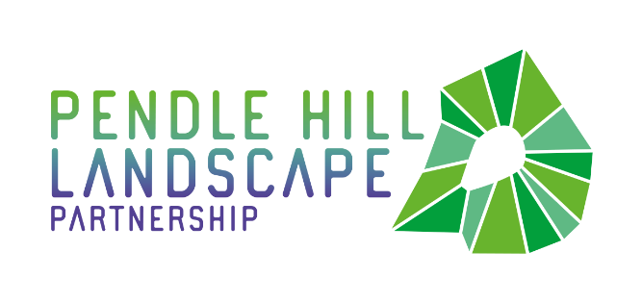
PRESS RELEASE
Pendle Hill Landscape Partnership extension granted
Tuesday 17th August 2021

The Pendle Hill Landscape Partnership has been awarded an extension to their 4-year delivery grant, working on projects across the Pendle Hill area. The original plan was to complete their objectives by March 2022, but the impact of the coronavirus has created the need for activity to take place during an additional summer in order to make up for lost time. With thanks to the National Lottery Heritage Fund they are now able to continue project delivery until 31st October 2022.

The Partnership aims to restore, enhance and conserve the heritage and landscape of Pendle Hill, reconnect people with their past and their landscape, bring the two sides of the hill together, and create a sustainable future for the environment, heritage and for visitors' experience of Pendle Hill. It was first launched in 2018 and is made up of dozens of projects, including Access for All, Traditional Boundaries, Wild About Pendle, Pendle Radicals, and Community Archaeology.
The Pendle Hill Landscape Partnership was nearing its halfway mark when the coronavirus arrived back in February 2020. Initially, it was considered it to be good timing for the project, as the subsequent March lockdown gave space to reflect on its successes and provided time to think about moving into stage 2 of the scheme. A number of contractor-led projects were still able to go ahead in line with government guidelines, including the creation of the Chatburn to Downham bridleway and refurbishing the Downham information barn nearby, plus hedge-laying and dry stone walling contracts on farms, and the Summit peat 'resilience' works.

As time moved on however, and the pandemic continued to progress, the enormity of the impact on the programme started to show. The continuous cancellations of planned activity meant that the scheme was falling further and further behind with meeting its objectives. Firstly, the archaeology forum was cancelled, then a hedge-laying competition, dry stone walling courses, volunteering days, the 'People Enjoying Nature' sessions, Little Saplings outdoor learning sessions, and school and family activities – all cancelled.
Some activities were adapted and instead delivered online, such as the Dark Skies events. Such events were hugely popular and enabled the project to reach new audiences - people who wouldn’t, or couldn't, normally join in. Projects thought creatively about how they could continue to engage with audiences, and carry out project work whilst working under restrictions, so there were some hugely positive things to take from lockdown as a result. In-Situ carried out events on-line and ran experimental 'testing Ground' artist residencies; the PEN project ran small group walks close to home and 2021's archaeology forum was a digital success! But the news of 'another summer' has been very much welcomed by the team. They are now able to revisit their plans for 2020 and begin to deliver projects and community engagement in 'real life' once more.
The programme is now back in full swing with plenty of dry stone walling taking place, new access routes being established, and summer holiday family events and the People Enjoying Nature sessions are back on. Next month a week-long walking festival will take place, alongside an event for Clarion Sunday run by Mid Pennine Arts. Next year will see three new woodlands planted up, lots more work on traditional boundaries, two more artists in residence, another archaeology internship and an extension to the much loved 72 Seasons project, which was a saviour to the people involved with it during the pandemic.
Talking about the extension, Programme Manager for the Pendle Hill Landscape Partnership Cathy Hopley said 'We are just so pleased and excited to be back outside, providing opportunities for people to get involved and hands-on with the landscape. Having this extension means we will be able to make up for lost time and deliver some really exciting things next year: watch this space!'

EDITORS NOTES
- The Pendle Hill landscape partnership is led by the Forest of Bowland AONB.
- The partnership aims to:
I. restore, enhance and conserve the heritage and landscape of Pendle Hill
II. reconnect people with their past and their landscape
III. bring the two sides of the hill together
IV. create a sustainable future for the environment, heritage and for visitors' experience of Pendle Hill
- The scheme was awarded a National Lottery grant of £1.8million by the National Lottery Heritage Fund in January 2018. These funds will be delivered from 2018-2022 and will be matched with a further £1m raised locally.
- The scheme is made up of a dozen projects which safeguard the area's wildlife and heritage and improve people's access to this popular countryside area. We will do this by providing opportunities for training and volunteering; by supporting research and devising creative and digital interpretation to inspire a new generation about our heritage; by restoring important landscape features, and by working with communities to re-tell the stories of radical Pendle people. The scheme will increase pride in this special place and raise aspirations amongst communities, and it will bring in new investment to support the environment and the economy.
- The Pendle Hill landscape partnership is supported by National Lottery players through the Heritage Fund and by the Forest of Bowland AONB. Partners include representatives of parish councils, the landowning and farming community, Pendle and Ribble Valley Borough Councils, Lancashire County Council, statutory bodies, tourism businesses and volunteers.
- Projects will be delivered by the AONB team, plus local delivery partners including In –Situ Arts, the Dry Stone Walling Association, Mid Pennine Arts and Ribble Rivers Trust.
- The Pendle Hill LP covers 120 square kilometres, stretching from Gisburn down to Whalley, and from Clitheroe across to Nelson and Padiham.
- The Hill is well known as a beauty spot and is heavily visited by residents of the local towns: it is a perfect place for walking and cycling. The area's heritage is dominated by the story of the Pendle Witches, but there are lots more stories to tell including the founding of the Quaker movement, non- conformists and radicals, Roman and Bronze Age settlers, medieval farming systems and early industrial developments. The network of dry stone walls and hedgerows give the area a distinctive feel, and the landscape is also important for its wild moorland, rare birds and woodlands.
- For further information contact the LP Scheme Manager cathy.hopley@lancashire.gov.uk on 07891 537835 / 01200 420420
- Visit the project website at www.pendlehillproject.com or visit our Facebook page 'Pendle Hill Project' for up to date news and views.
About the National Lottery Heritage Fund
Using money raised by the National Lottery, we Inspire, lead and resource the UK's heritage to create positive and lasting change for people and communities, now and in the future. www.heritagefund.org.uk
Follow @HeritageFundUK on Twitter, Facebook and Instagram and use #NationalLotteryHeritageFund

