PRESS RELEASE

For immediate release Wednesday 28th July 2021
Get out in Nature this Summer
East Lancashire families can have a wild adventure this summer
Summer holiday adventures await local Pendle Hill families
The Pendle Hill Landscape Partnership are inviting local families to get outside and discover local heritage spots this summer through free family events and online guides. During lockdown, East Lancashire families took time to explore their local green spaces, appreciating the change in seasons and nature on their doorstep. Now local families can appreciate these wild spaces with other friends and family, sharing their favourite walks, birding spots or wildflower meadows. Families have even attended free nature events and outdoor toddler groups, provided by the Pendle Hill Landscape Partnership.
The outdoor family events are back within the Pendle Hill Landscape, and offering more opportunities for families to spark an interest in wildlife, explore their local area and learn about the history of the Pendle Hill area. During the summer holidays, families can ramble through the landscape on guided walks, discover minibeasts within the woods, become an archaeologist for the day, learn about traditional boundaries and even have a go at building a dry stone wall. All events are booking essential via the website https://www.pendlehillproject.com/whats-on
The National Lottery Heritage Funded Landscape Partnership scheme started in April 2018. The projects' Outdoor Learning Officer Alison, who is funded by the Ernest Cook Trust, has been delivering free family events since summer 2018. These take place within local parks, nature reserves and heritage buildings. Alison has been looking forward to delivering these sessions again. "I love the moments when I get to reconnect local families with the countryside and show them something new and exciting. Recently it was spotting the four different stages of a ladybird life cycle that both parent and child were in awe of." This year's locations include Lancashire County Councils Clitheroe Castle, Barrowfords' Pendle Heritage Centre and the Downham visitor centre.
Families can also go on their own adventure this year using the Pendle Hill's Project new Explore section on the website. https://www.pendlehillproject.com/explore There is free walking and cycling routes, printable nature resources for young ones and even helpful guides about how to access the countryside and keep yourself safe. "It is very important when anyone steps into the countryside they follow the countryside code. This helps to keep themselves, other visitors, the wildlife around them and the people who work within the landscape safe. Do remember to respect, protect and enjoy every moment in the great outdoors."
The Pendle Hill Project also delivers an outdoor toddler group called Little Saplings, for under 5 year olds. These events returned in May as mini versions, with the hope for Little saplings to fully return this September. The one-and-a-half-hour sessions take place at Spring Wood picnic site, Whalley and Victoria Park, Nelson. Each outdoor event allows parents, carers, and their little ones to explore the woodland at their own pace, joining in with various activities that range from mud painting to bug hunting. The aim is for the children to develop life skills using the Forest School ethos. While parents enjoy family time in nature and learn new activities they can repeat at home or in another green space. A parent described the toddler group as "A wonderful, well supported, interactive session for children to learn and explore the outdoors". More information about these free events can be found on the website https://www.pendlehillproject.com/little-saplings
Outdoor Learning Officer Alison looks forward to meeting more local families in the future “In the Autumn I hope families can be back in mud kitchen making yummy soup or searching for the Gruffalo within the woods. It is wonderful to watch children at any age be inspired by an activity, learn something new about our heritage or create a deeper connection with the natural world." "I couldn't provide these free sessions if it wasn't for our funders and the kindness of our volunteers". Alison is always looking for new volunteers to assist her with school trip delivery, family events and the Little Sapling toddler group.
If you would like to find out more about Pendle Hill Landscape Partnership family events and volunteering opportunities, then get in touch with the team at https://www.pendlehillproject.com or email: volunteer@pendle-hill-lp.co.uk

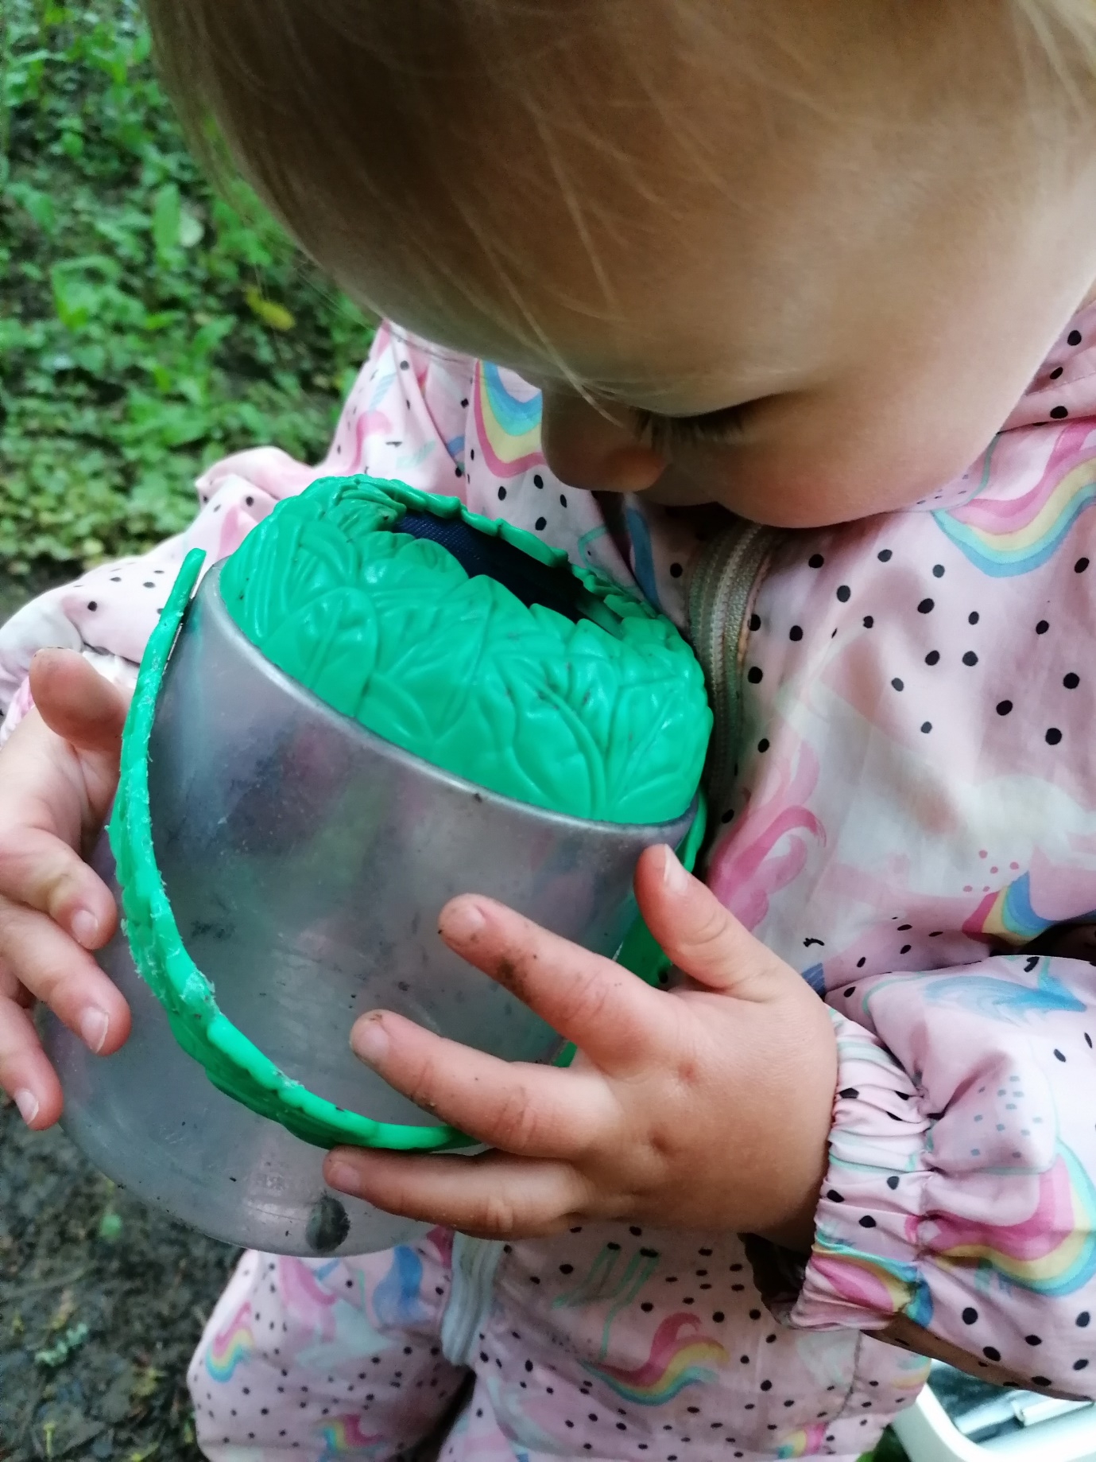
Toddler hunts for bugs in the woods at Little Saplings
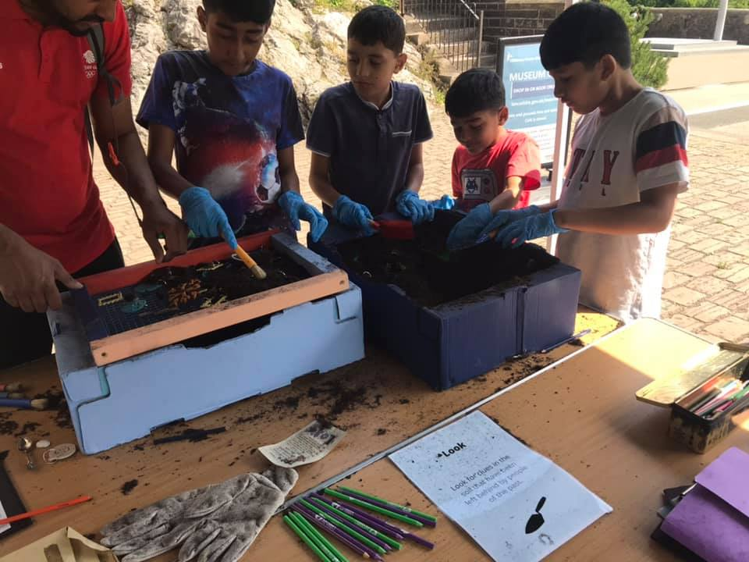
A family becomes archaeologist for the day at Clitheroe Castle.
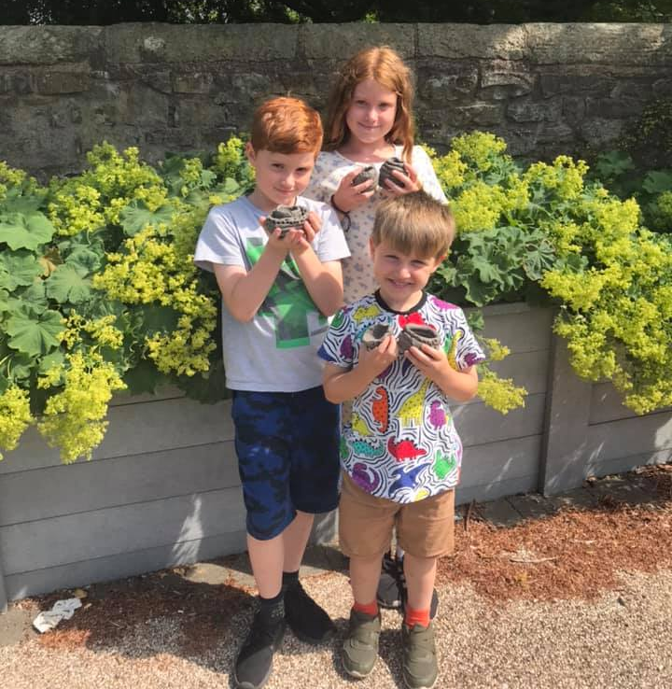
Children create traditional clay pots at Pendle Hill family Event

EDITORS NOTES

- The Pendle Hill landscape partnership is led by the Forest of Bowland AONB.
- The partnership aims to:
I. restore, enhance and conserve the heritage and landscape of Pendle Hill
II. reconnect people with their past and their landscape
III. bring the two sides of the hill together
IV. create a sustainable future for the environment, heritage and for visitors' experience of Pendle Hill
- The scheme was awarded a National Lottery grant of £1.8million by the National Lottery Heritage Fund in January 2018. These funds will be delivered from 2018-2022 and will be matched with a further £1m raised locally.
- The scheme is made up of a dozen projects which safeguard the area's wildlife and heritage and improve people's access to this popular countryside area. We will do this by providing opportunities for training and volunteering; by supporting research and devising creative and digital interpretation to inspire a new generation about our heritage; by restoring important landscape features, and by working with communities to re-tell the stories of radical Pendle people. The scheme will increase pride in this special place and raise aspirations amongst communities, and it will bring in new investment to support the environment and the economy.
- The Pendle Hill landscape partnership is supported by National Lottery players through the Heritage Fund and by the Forest of Bowland AONB. Partners include representatives of parish councils, the landowning and farming community, Pendle and Ribble Valley Borough Councils, Lancashire County Council, statutory bodies, tourism businesses and volunteers.
- Projects will be delivered by the AONB team, plus local delivery partners including In –Situ Arts, the Dry Stone Walling Association, Mid Pennine Arts and Ribble Rivers Trust.
- The Pendle Hill LP covers 120 square kilometres, stretching from Gisburn down to Whalley, and from Clitheroe across to Nelson and Padiham.
- The Hill is well known as a beauty spot and is heavily visited by residents of the local towns: it is a perfect place for walking and cycling. The area's heritage is dominated by the story of the Pendle Witches, but there are lots more stories to tell including the founding of the Quaker movement, non- conformists and radicals, Roman and Bronze Age settlers, medieval farming systems and early industrial developments. The network of dry stone walls and hedgerows give the area a distinctive feel, and the landscape is also important for its wild moorland, rare birds and woodlands.
- For further information contact the LP Scheme Manager cathy.hopley@lancashire.gov.uk on 07891 537835 / 01200 420420
- Visit the project website at www.pendlehillproject.com or visit our Facebook page 'Pendle Hill Project' for up to date news and views.
About the National Lottery Heritage Fund
Using money raised by the National Lottery, we Inspire, lead and resource the UK's heritage to create positive and lasting change for people and communities, now and in the future. www.heritagefund.org.uk
Follow @HeritageFundUK on Twitter, Facebook and Instagram and use #NationalLotteryHeritageFund

