PRESS RELEASE
23.08.2021
FOR IMMEDIATE RELEASE
Together For Our Landmark – New to Walking Festival

FREE 9 day walking festival - Together for Our Landmark - Saturday 18th to Sunday 26th September.

Did you enjoy regular walks from home during lockdown? But need some further ideas of where to explore? Participate in the 'New to Walking' Festival and experience the Pendle Hill area with the support of knowledgeable guides. Learn more about the area's fascinating natural and cultural heritage, find some hidden gems away from the crowds and gain confidence to venture out on self-guided walks in the future!
Hetty Byrne, Sustainable Tourism Officer for Forest of Bowland AONB said: 'The Pendle Hill area has so much to offer for those seeking adventure, exploring history or for a family day out, but all too often people flock to the same busy spots, perhaps gaining reassurance by following the crowds. One part of the Pendle Hill Landscape Partnership Scheme has been to look at spreading some of that visitor pressure from the same 'honeypot' sites and encouraging people to seek out all the opportunities that the area has to offer. This led us to the idea of organising a walking festival to highlight all these wonderful opportunities, on all sides of the hill.'
From 18th to 26th September The Pendle Hill Landscape Partnership are excited to present a 'new to walking festival' – Together for our Landmark - to further extend walking from home and the connections made during Lockdown. The guided walks will be an opportunity for people to continue with the regular walks they have enjoyed and to develop their confidence to explore new walks in the Pendle Hill Landscape Partnership area. It is also an opportunity for people to learn more about the natural and cultural heritage of the area.
Hetty said: 'We've got such a varied programme from archaeology to herbal medicine, mindfulness to traditional boundaries and family-friendly walks. The guided walks start from locations all around Pendle Hill including Nelson, Barrowford, Sabden, Roughlee and Downham. We've kept the walks to a maximum of 6 miles, but they include a variety of terrain, so we hope there is something for everyone!'
The walks are all free, but donations are welcome on the day contributing to Rossendale and Pendle Mountain Rescue and the Pendle Hill Fund.
For full details of the walks and information about how to book, please visit: www.pendlehillproject.com/walking-festival
Be sure to book early as walk sizes are being kept to a small and manageable amount, so they will book up quickly!
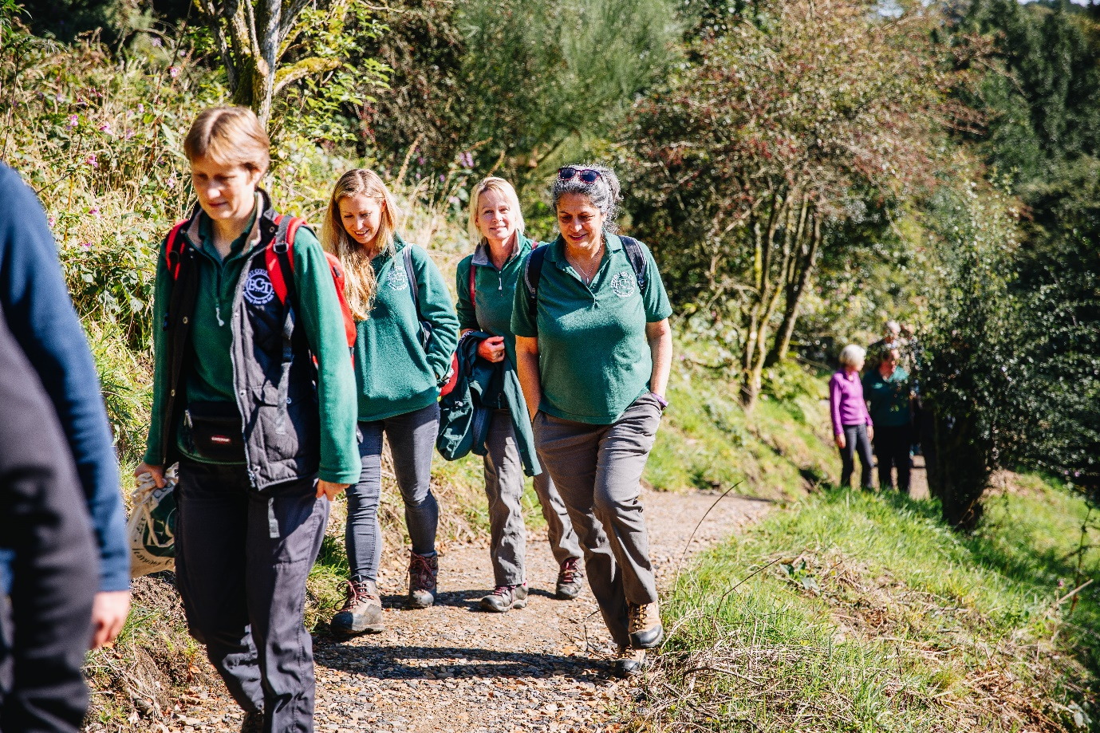Image: Outdoor Learning Funders Day © Lucy Judson
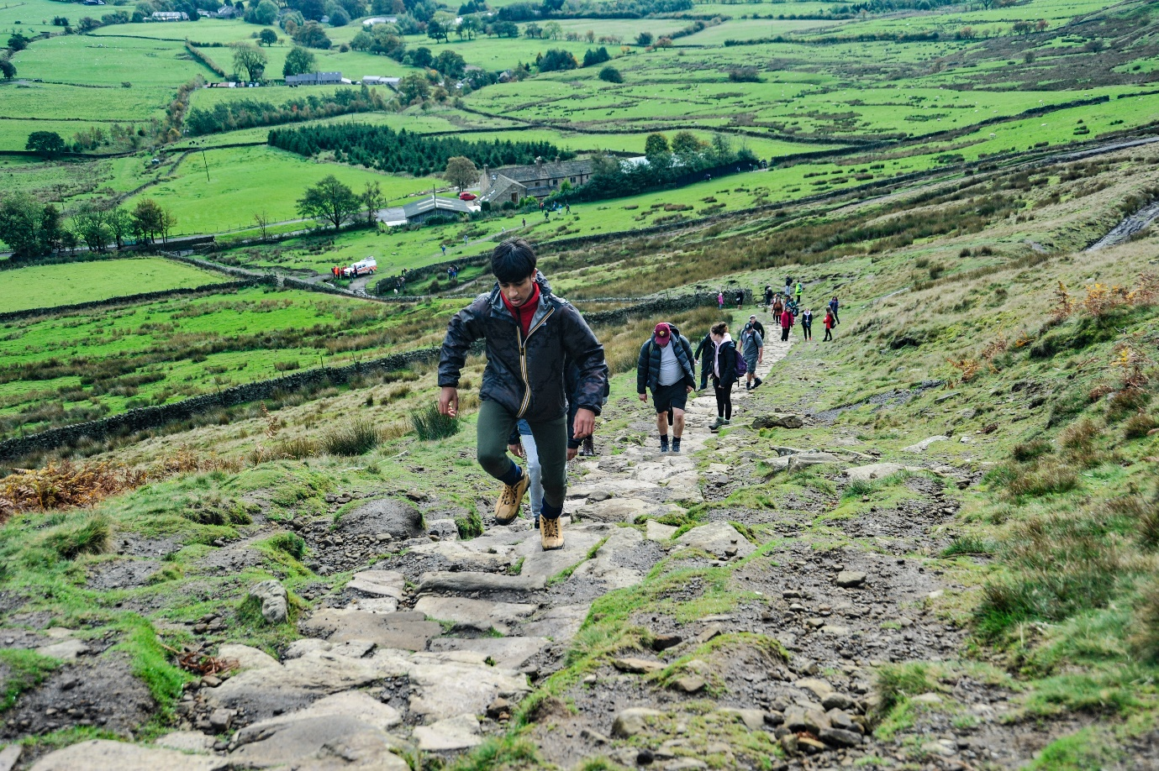
Image: Pendle Hill Landscape Partnership Launch Event 2018 © Mark Sutcliffe

EDITORS NOTES
- The Pendle Hill landscape partnership is led by the Forest of Bowland AONB.
- The partnership aims to:
I. restore, enhance and conserve the heritage and landscape of Pendle Hill
II. reconnect people with their past and their landscape
III. bring the two sides of the hill together
IV. create a sustainable future for the environment, heritage and for visitors' experience of Pendle Hill
- The scheme was awarded a National Lottery grant of £1.8million by the National Lottery Heritage Fund in January 2018. These funds will be delivered from 2018-2022 and will be matched with a further £1m raised locally.
- The scheme is made up of a dozen projects which safeguard the area's wildlife and heritage and improve people's access to this popular countryside area. We will do this by providing opportunities for training and volunteering; by supporting research and devising creative and digital interpretation to inspire a new generation about our heritage; by restoring important landscape features, and by working with communities to re-tell the stories of radical Pendle people. The scheme will increase pride in this special place and raise aspirations amongst communities, and it will bring in new investment to support the environment and the economy.
- The Pendle Hill landscape partnership is supported by National Lottery players through the Heritage Fund and by the Forest of Bowland AONB. Partners include representatives of parish councils, the landowning and farming community, Pendle and Ribble Valley Borough Councils, Lancashire County Council, statutory bodies, tourism businesses and volunteers.
- Projects will be delivered by the AONB team, plus local delivery partners including In –Situ Arts, the Dry Stone Walling Association, Mid Pennine Arts and Ribble Rivers Trust.
- The Pendle Hill LP covers 120 square kilometres, stretching from Gisburn down to Whalley, and from Clitheroe across to Nelson and Padiham.
- The Hill is well known as a beauty spot and is heavily visited by residents of the local towns: it is a perfect place for walking and cycling. The area's heritage is dominated by the story of the Pendle Witches, but there are lots more stories to tell including the founding of the Quaker movement, non- conformists and radicals, Roman and Bronze Age settlers, medieval farming systems and early industrial developments. The network of dry stone walls and hedgerows give the area a distinctive feel, and the landscape is also important for its wild moorland, rare birds and woodlands.
- For further information contact the LP Scheme Manager cathy.hopley@lancashire.gov.uk on 07891 537835 / 01200 420420
- Visit the project website at www.pendlehillproject.com or visit our Facebook page 'Pendle Hill Project' for up to date news and views.
About the National Lottery Heritage Fund
Using money raised by the National Lottery, we Inspire, lead and resource the UK's heritage to create positive and lasting change for people and communities, now and in the future. www.heritagefund.org.uk
Follow @HeritageFundUK on Twitter, Facebook and Instagram and use #NationalLotteryHeritageFund

