Release date: Tuesday 16th July 2019

New Family Treasure Trails within Pendle Hill Landscape

Are you planning your summer days out with the children, and looking for exciting things to do close to home? Two new family Treasure Trails based around the Pendle villages of Sabden and Barrowford could be just what you are looking for.
The Pendle Hill Landscape Partnership project are launching the Trails as part of the 'Discover Pendle Hill' sustainable tourism project.
Pupils from local primary schools have helped to create the Treasure Trails. Year 5s from Barrowford and Sabden schools have been working with the Treasure Trail Company to create family self-guided and quiz based walks within the local landscape. The children spent several days out exploring their home villages looking at heritage and places of interest and devising a series of clues that will guide you to the site of 'buried treasure'.
Stuart Marshall, treasure trail partner, was commissioned to create the trails with the schools. "The year 5's have really enjoyed learning about their local history and geography, village landmarks and how to write clear instructions. They have learnt a lot about the area and its history. The two treasure trails are now ready to sell before summer holidays". The Trail leaflets will be on sale at Sanwitches Café and the Milking Parlour in Sabden, and at the Pendle Heritage Centre, Booths and Coffee & Crafts in Barrowford. Follow the Pendle Hill Project website or Facebook page to find out where else the trails are on sale, costing just £2.50 each.
A Barrowford St Thomas year 5 teacher said "The activities were engaging and the resources supplied were excellent. We will use the experiences for orienteering and small school ground treasure hunts" All schools involved have benefited from the fully funded opportunity, with thanks to The Ernest Cook Trust and National Lottery Heritage Fund. An extra bonus was through working with two schools in Barrowford, the schools thanked us for the "opportunity to not only make links with another school, but to take part in this fantastic project. It really got the children using lots of skills and they thoroughly enjoyed it".
Sabden resident Margaret Wright, along with grandsons Oliver McCullough (nine) and Joseph Cookson (eight), think the Sabden Treasure Trail is great. They were the first family to use the trail while walking around their village. Margaret said: "The boys loved it and so did I. It was definitely a team effort working out the directions and the clues. And there was loads of information about Sabden that was good too. The Trail is perfect for all ages, for visitors to Sabden and for villagers too. I'd do it again!"
If you would like to find out more about other Pendle Hill Landscape Partnership family events and working with schools, then get in touch with the team at https://pendlehillproject.com/get-involved or email: volunteer@pendle-hill-lp.co.uk or call 01200 420420.
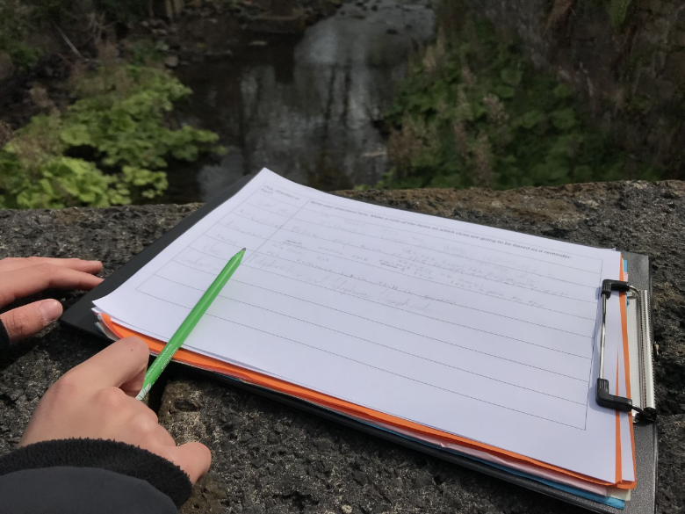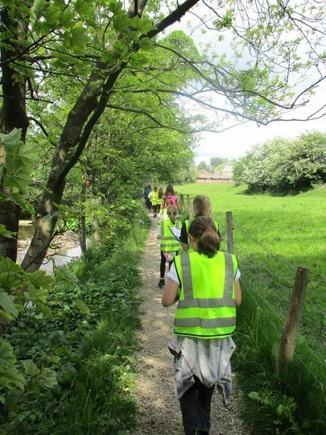
Photos: Barrowford pupils exploring their village and devising the clues for the Treasure Trails

EDITORS NOTES
- The Pendle Hill landscape partnership is led by the Forest of Bowland AONB.
- The partnership aims to:
I. restore, enhance and conserve the heritage and landscape of Pendle Hill
II. reconnect people with their past and their landscape
III. bring the two sides of the hill together
IV. create a sustainable future for the environment, heritage and for visitors' experience of Pendle Hill
- The scheme was awarded a National Lottery grant of £1.8million by the Heritage Lottery Fund in January 2018. These funds are beingl be delivered from 2018-2022 and will be matched with a further £1m raised locally.
- The scheme is made up of a dozen projects which safeguard the area's wildlife and heritage and improve people's access to this popular countryside area. We will do this by providing opportunities for training and volunteering; by supporting research and devising creative and digital interpretation to inspire a new generation about our heritage; by restoring important landscape features, and by working with communities to re-tell the stories of radical Pendle people. The scheme will increase pride in this special place and raise aspirations amongst communities, and it will bring in new investment to support the environment and the economy.
- The Pendle Hill landscape partnership is supported by National Lottery players through the Heritage Fund and by the Forest of Bowland AONB. Partners include representatives of parish councils, the landowning and farming community, Pendle and Ribble Valley Borough Councils, Lancashire County Council, statutory bodies, tourism businesses and volunteers.
- Projects are delivered by the AONB team, plus local delivery partners including In –Situ Arts, the Dry Stone Walling Association, Mid Pennine Arts and Ribble Rivers Trust.
- The Pendle Hill LP covers 120 square kilometres, stretching from Gisburn down to Whalley, and from Clitheroe across to Nelson and Padiham.
- The Hill is well known as a beauty spot and is heavily visited by residents of the local towns: it is a perfect place for walking and cycling. The area's heritage is dominated by the story of the Pendle Witches, but there are lots more stories to tell including the founding of the Quaker movement, non- conformists and radicals, Roman and Bronze Age settlers, medieval farming systems and early industrial developments. The network of dry stone walls and hedgerows give the area a distinctive feel, and the landscape is also important for its wild moorland, rare birds and woodlands.
- For further information contact the LP Scheme Manager cathy.hopley@lancashire.gov.uk on 07891 537835 / 01200 420420
- Visit the project website at www.pendlehillproject.com or visit our Facebook page 'Pendle Hill Project' for up to date news and views.

About the Heritage Fund
Thanks to National Lottery players, we invest money to help people across the UK explore, enjoy and protect the heritage they care about - from the archaeology under our feet to the historic parks and buildings we love, from precious memories and collections to rare wildlife. www.hlf.org.uk Follow us on Twitter, Facebook and Instagram and use #HLFsupported

About The Ernest Cook Trust
The Outdoor Learning project is led by the Outdoor Learning Officer, who is employed through the Ernest Cook Trust. ECT was founded as an educational trust by Ernest Cook, grandson of Thomas Cook (the travel agent), in 1952. ECT's vision is inspiring young people to achieve better education and life outcomes by learning from the land. In order to increase this reach they have begun to partner with a range of organisations in different parts of the UK, hence their involvement with the Pendle Hill Landscape Partnership. The Outdoor Learning Officer will provide a key role in broadening learning aspects of the PHLP, providing additional family activities and formal education methods to engage with the PHLP community

