PRESS RELEASE
THE PENDLE HILL LANDSCAPE PARTNERSHIP IS 2 YEARS OLD!
24th June 2020
It's been a busy second year for the Pendle Hill Landscape Partnership. 14 different projects are currently under way, making a positive impact on the landscape of the area, and helping to re-connect people to the hill and its heritage. The illustration shows some of the key achievements of the partnership in year 2.
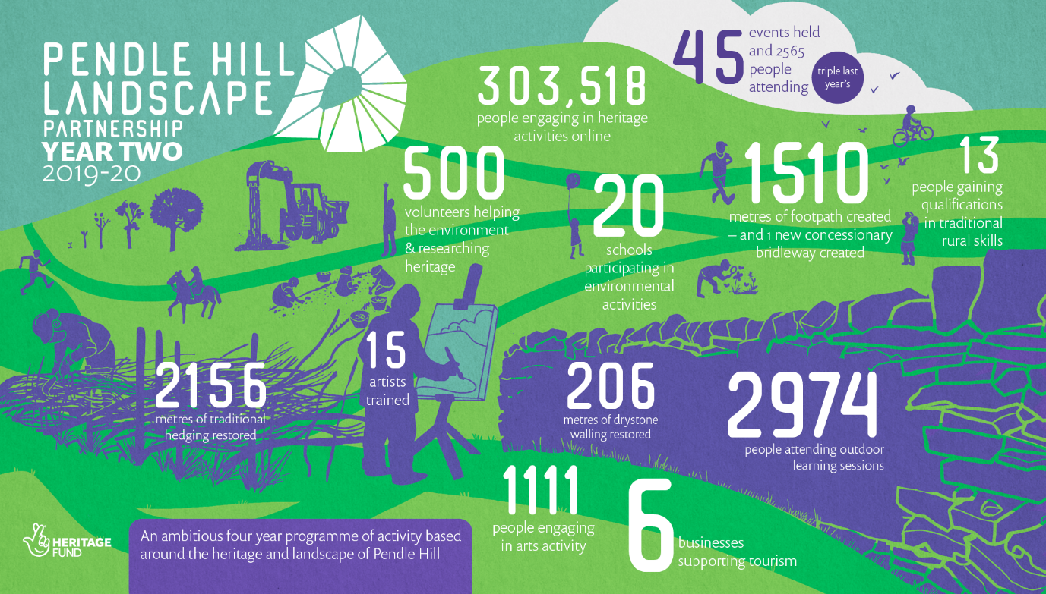

The work will continue for at least a further two years, and the team are looking forward to getting back outdoors to run many more new activities, community events and opportunities for people to learn more about Pendle Hill's fantastic landscape and local heritage.
Highlights for year 2 include:
- The unveiling of the Pendle Mobile Hut at the Garage in Brierfield as part of an annual Gathering event
- The creation of a new bridleway linking Chatburn with Downham; and the refurbishment of the Information Barn in Downham
- A vast programme of free outdoor learning events for schools and toddlers, as well as numerous family events during the school holidays
- continuing opportunities for volunteering through our programme of regular practical conservation days; plus activities for People Enjoying Nature which is our project supporting people dealing with mental health and social isolation issues
- another chance to apply for funds for community heritage schemes in the LP area
- The restoration of over 2 kilometres of traditional hedging

The partnership's annual Gathering event, run by In Situ, will take place as The Digital Gatherings this year. The event is split into four topic areas and will be held weekly throughout August. The events will be as follows:
- 5th August - Traditions, Stories and Folklore
- 12th August – Interventions into the Landscape
- 19th August – Sustainable Tourism and Increasing Access to the Hill for Everyone
- 26th August – The Future of Communities Around Pendle Hill
More information and a link to book your place can be found on the Pendle Hill Project website and Facebook page.

ENDS

EDITORS NOTES
- The Pendle Hill landscape partnership is led by the Forest of Bowland AONB.
- The partnership aims to:
I. restore, enhance and conserve the heritage and landscape of Pendle Hill
II. reconnect people with their past and their landscape
III. bring the two sides of the hill together
IV. create a sustainable future for the environment, heritage and for visitors' experience of Pendle Hill
- The scheme was awarded a National Lottery grant of £1.8million by the National Lottery Heritage Fund in January 2018. These funds will be delivered from 2018-2022 and will be matched with a further £1m raised locally.
- The scheme is made up of a dozen projects which safeguard the area's wildlife and heritage and improve people's access to this popular countryside area. We will do this by providing opportunities for training and volunteering; by supporting research and devising creative and digital interpretation to inspire a new generation about our heritage; by restoring important landscape features, and by working with communities to re-tell the stories of radical Pendle people. The scheme will increase pride in this special place and raise aspirations amongst communities, and it will bring in new investment to support the environment and the economy.
- The Pendle Hill landscape partnership is supported by National Lottery players through the Heritage Fund and by the Forest of Bowland AONB. Partners include representatives of parish councils, the landowning and farming community, Pendle and Ribble Valley Borough Councils, Lancashire County Council, statutory bodies, tourism businesses and volunteers.
- Projects will be delivered by the AONB team, plus local delivery partners including In –Situ Arts, the Dry Stone Walling Association, Mid Pennine Arts and Ribble Rivers Trust.
- The Pendle Hill LP covers 120 square kilometres, stretching from Gisburn down to Whalley, and from Clitheroe across to Nelson and Padiham.
- The Hill is well known as a beauty spot and is heavily visited by residents of the local towns: it is a perfect place for walking and cycling. The area's heritage is dominated by the story of the Pendle Witches, but there are lots more stories to tell including the founding of the Quaker movement, non- conformists and radicals, Roman and Bronze Age settlers, medieval farming systems and early industrial developments. The network of dry stone walls and hedgerows give the area a distinctive feel, and the landscape is also important for its wild moorland, rare birds and woodlands.
- For further information contact the LP Scheme Manager cathy.hopley@lancashire.gov.uk on 07891 537835 / 01200 420420
- Visit the project website at www.pendlehillproject.com or visit our Facebook page 'Pendle Hill Project' for up to date news and views.
About the Heritage Fund
Thanks to National Lottery players, we invest money to help people across the UK explore, enjoy and protect the heritage they care about - from the archaeology under our feet to the historic parks and buildings we love, from precious memories and collections to rare wildlife. www.hlf.org.uk Follow us on Twitter, Facebook and Instagram and use #HLFsupported

