PRESS RELEASE
For immediate release 16th June 2020
Enhancing enchanting meadows
Lancashire meadows are currently in full bloom, including those within the Pendle Hill Landscape Partnership area. One particular meadow in Sabden received some vital restoration two years ago and this year it is looking blooming marvellous.

Cockshotts Farm near Sabden were looking for a way to enhance their grasslands for wildlife. Farmer Edward Gill says, "I always remember my Gran saying her favourite thing about this farm was the meadow, and the amount of butterflies fluttering over it in the summer. I wanted to restore the meadow which has never had any pesticides or fertilisers added to it, but recently has been a bit neglected." In 2018, Edward approached Sarah Robinson at the newly developed Pendle Hill project. "I was looking for some guidance, as I wanted the meadow to be brimming with life for my children to admire in the future." Edward asked Pendle Hill's Landscape Partnership team for some assistance and support. The partnership team jumped at the chance to help restore the meadow for biodiversity.
Sarah Robinson, the team's Farming and Wildlife Officer worked with the Gill family to put Edwards plan into action. "We started off by taking soil samples to ensure the meadow seed we were going to add would thrive. The traditional grasses and wildflowers we wanted to use do not do well in high nutrient soils. Then we added seed taken from a species rich hay meadow in Slaidburn and planted plug plants of particular wildflowers such as ox-eye daisy and meadow vetchling. This type of restoration in a long term project, but after two years, we are starting to see results. Its great working with such enthusiastic and dedicated people. "
Edward and the family are really impressed with the meadow "after 2 years of hard work, we have a tenfold increase of invertebrates on site, plus lots more birds in the area. This project has been really exciting and I can't thank Sarah and the team enough".
Sarah is now looking at other local meadows to restore for the future, to provide more species rich habitats and nectar patches around the Pendle Hill Landscape area. Working with the Pendle Hill Farmers Network the project will help to restore lost species back to the meadows and rebuild the network of sites providing pollen and nectar for bees and butterflies. During spring and summer, the array of colourful flowers and grasses in meadows make not only a wonderful sight but create important places for other species such as bats and birds to feed and nest in. This important habitat is missing from much of the local countryside.
Other farmers in the area are now looking to enhance their grasslands. They will be joining the meadow restoration project, which is part of Wild about Pendle, one of the projects funded by the National Lottery Heritage Fund within the Pendle Hill Landscape Partnership. Sarah says, "At the moment we are looking for sites within the Pendle Hill area where people would like to restore the characteristic wildflowers to their hay meadows."
Meadows are an important feature in the landscape, and there is even a National Meadows day every year on the first Saturday in July. This year, it falls on Saturday 4th July and everyone is welcome to celebrate meadows virtually, through an online event organised by Sarah and the Forest of Bowland AONB team. More details and to book a free online space head to https://www.forestofbowland.com/online-events-learning
Families are being encouraged to take notice of wildflowers and plant their own nectar rich patch if possible. Growing a variety of plants in the garden produces a long flowering period, and ensures a steady supply of nectar and pollen. Fruit trees and soft fruit bushes are a fantastic addition. The RHS, Bumblebee Conservation Trust, Plantlife and Buglife charities have many useful tips and how to guides.

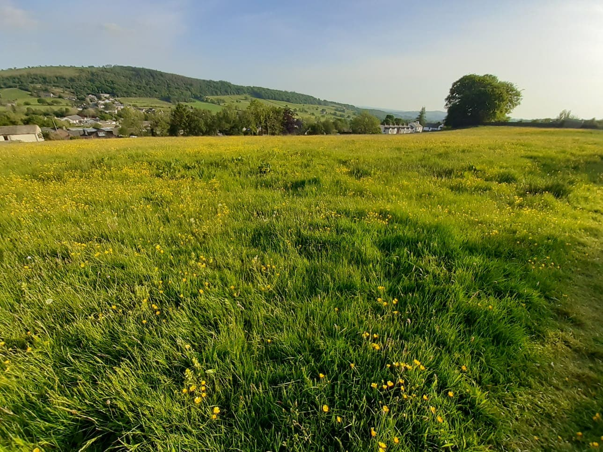
Cockshotts Farm meadow June 2020
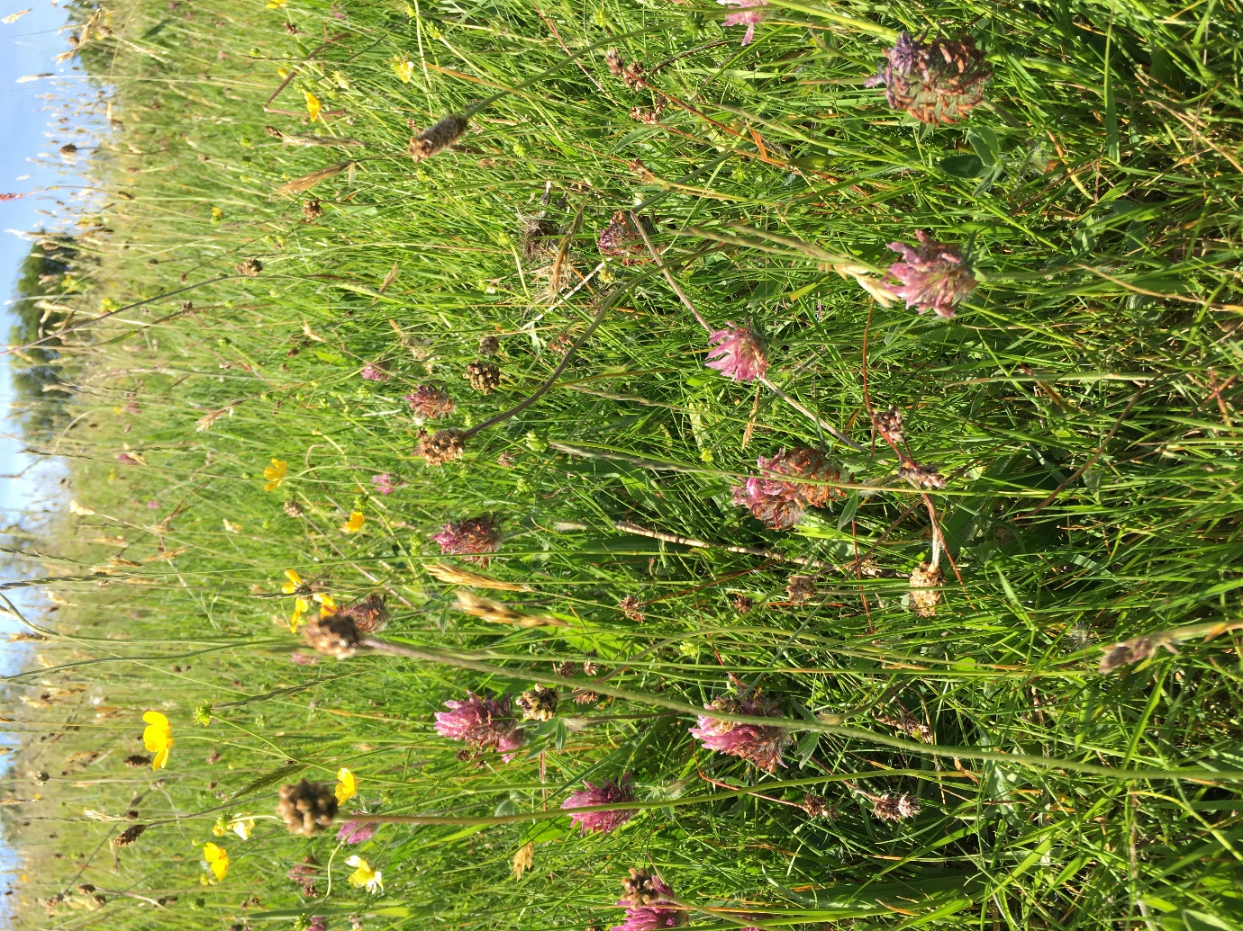
Cockshotts Farm meadow May2020
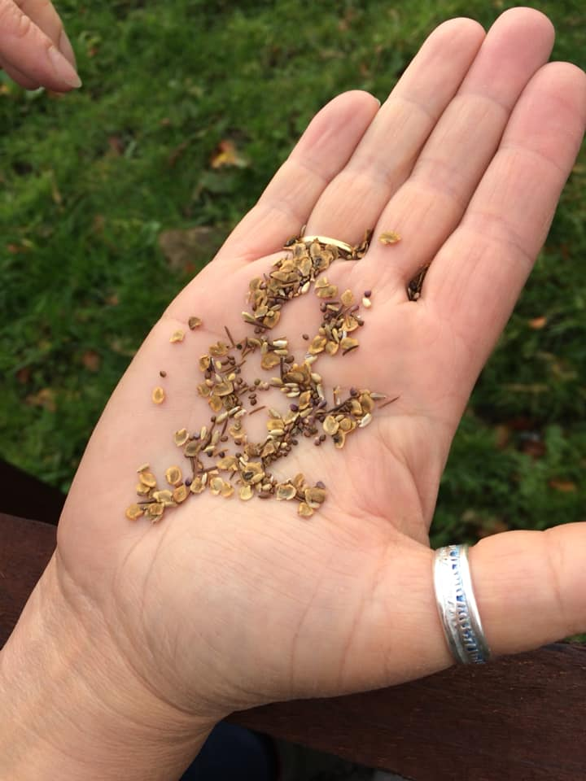
Seed to spread in Autumn 2018
EDITORS NOTES
- The Pendle Hill landscape partnership is led by the Forest of Bowland AONB.
- The partnership aims to:
I. restore, enhance and conserve the heritage and landscape of Pendle Hill
II. reconnect people with their past and their landscape
III. bring the two sides of the hill together
IV. create a sustainable future for the environment, heritage and for visitors' experience of Pendle Hill
- The scheme was awarded a National Lottery grant of £1.8million by the National Lottery Heritage Fund in January 2018. These funds will be delivered from 2018-2022 and will be matched with a further £1m raised locally.
- The scheme is made up of a dozen projects which safeguard the area's wildlife and heritage and improve people's access to this popular countryside area. We will do this by providing opportunities for training and volunteering; by supporting research and devising creative and digital interpretation to inspire a new generation about our heritage; by restoring important landscape features, and by working with communities to re-tell the stories of radical Pendle people. The scheme will increase pride in this special place and raise aspirations amongst communities, and it will bring in new investment to support the environment and the economy.
- The Pendle Hill landscape partnership is supported by National Lottery players through the Heritage Fund and by the Forest of Bowland AONB. Partners include representatives of parish councils, the landowning and farming community, Pendle and Ribble Valley Borough Councils, Lancashire County Council, statutory bodies, tourism businesses and volunteers.
- Projects will be delivered by the AONB team, plus local delivery partners including In –Situ Arts, the Dry Stone Walling Association, Mid Pennine Arts and Ribble Rivers Trust.
- The Pendle Hill LP covers 120 square kilometres, stretching from Gisburn down to Whalley, and from Clitheroe across to Nelson and Padiham.
- The Hill is well known as a beauty spot and is heavily visited by residents of the local towns: it is a perfect place for walking and cycling. The area's heritage is dominated by the story of the Pendle Witches, but there are lots more stories to tell including the founding of the Quaker movement, non- conformists and radicals, Roman and Bronze Age settlers, medieval farming systems and early industrial developments. The network of dry stone walls and hedgerows give the area a distinctive feel, and the landscape is also important for its wild moorland, rare birds and woodlands.
- For further information contact the LP Scheme Manager cathy.hopley@lancashire.gov.uk on 07891 537835 / 01200 420420
- Visit the project website at www.pendlehillproject.com or visit our Facebook page 'Pendle Hill Project' for up to date news and views.
About the Heritage Fund
Thanks to National Lottery players, we invest money to help people across the UK explore, enjoy and protect the heritage they care about - from the archaeology under our feet to the historic parks and buildings we love, from precious memories and collections to rare wildlife. www.hlf.org.uk Follow us on Twitter, Facebook and Instagram and use #HLFsupported

