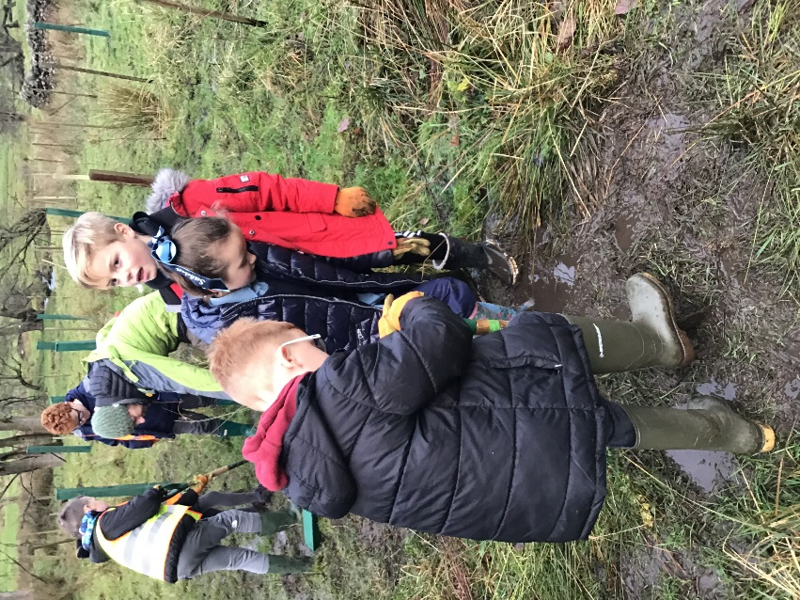

Children getting ‘stuck in’ planting along Sabden Brook.

PRESS RELEASE
Schools, volunteers and charities team together to plant new woodlands for the future

This winter, 103 children from primary schools in Sabden, Chatburn and Gisburn have helped to create new woodlands for our rivers and wildlife. Together, the children planted over 100 trees along the picturesque banks of both Twiston Beck, near to Twiston Mill, and Sabden Brook, downstream of the village.

The children were supported by staff and volunteers from the Ribble Rivers Trust and the Pendle Hill Landscape Partnership team through projects funded by players of the National Lottery and Esme Fairburn Foundation. The Ribble Life Together and Pendle WINNS (Woodland and Invasive Non-Native Species) projects are allowing these valuable links between the charities to enrich the experiences for all involved. Through these projects, many more volunteers from local communities have also been involved in actively conserving their landscape and the rivers flowing through them.
Quote from A. Teacher:

Education and Engagement Officer at the Ribble Rivers Trust, Emily Bateman, said “As well as fun day out for the children full of hands-on opportunities to learn through real-life conservation work, we hope that the children enjoy the woodlands that they have created alongside the rest of the community and wildlife that they will benefit well into the future. The trees will grow tall as a very visual local reminder of the children’s place within this landscape and the positive influence that they can have on it.”

Quote from Alison The Pendle Hill Landscape Partnership Outdoor Learning Officer,: "Working in partnership with the Ribble Rivers Trust and local primary schools really helps to bring the community together on big conservation projects. There are 28,617 trees to plant for the four years Pendle Hill Project, so we are looking for other local schools and organisations to help us create new habitats." You can get involved via www.pendlehillproject.com or pendlehill.lp@lancashire.gov.uk

These new woodlands, along with other planted this winter, will offer habitats and food for an array of wildlife. The roots will protect the land from erosion and leaves will give much needed shade, that will cool the water for fish and invertebrates over the warm summer months. By slowing the flow of water in these upland areas, woodlands can also help to reduce the impact, further down the river’s catchment, of heavy rainfall events.

For more information about the work of the Ribble Rivers Trust to improve our local rivers and our schools programme, visit ribblelifetogether.org/learn or contact us on 01200 444452.

Notes to editor

The Ribble Rivers Trust (RRT) is a local environmental charity established in 1997 to protect and restore the rivers, streams and watercourses within the Ribble catchment and to raise public awareness of the value of our local rivers and streams. The Ribble catchment is the area of land that is drained by the River Ribble and its major tributaries; the Hodder, Calder and Darwen. It covers a varied landscape, from the rural hills of the Yorkshire Dales and the source of the River Ribble, to major urban areas of Lancashire including Blackburn, Burnley and Preston. For more information please contact admin@ribbletrust.com, call 01200 444452 or visit www.ribbletrust.org.uk

Ribble Life Together
Ribble Life Together is delivering a healthier river system for the benefit and enjoyment of local communities and local wildlife. This ambitious project brings many organisations together who all have a common goal of improving water quality, reducing the risk of flooding and droughts and increasing river connectivity and biodiversity. Ribble Life Together is exploring and celebrating the rich heritage of the river and encouraging more people to discover the wonder of the river for themselves.
Funding for the project comes from the Heritage Lottery Fund and others, more information on ribblelifetogether.org.uk

The Heritage Lottery Fund
Thanks to National Lottery players, we invest money to help people across the UK explore, enjoy and protect the heritage they care about - from the archaeology under our feet to the historic parks and buildings we love, from precious memories and collections to rare wildlife. www.hlf.org.uk. Follow us on Twitter, Facebook and Instagram and use #NationalLottery and #HLFsupported.

Pendle WINS Project
Pendle WINS is a partnership project between The Ribble Rivers Trust, Yorkshire Dales Millennium Trust, the Forest of Bowland AONB, and the Woodland Trust. It sits within the Forest of Bowland’s Heritage Lottery Fund Pendle Hill Landscape Partnership Scheme (LPS). Pendle WINS involves woodland creation & management and invasive non-native species (INNS) control. These activities also offer opportunities for community participation and promote the health and wellbeing of those involved.

AONB & Pendle Hill Landscape Partnership
- The Pendle Hill landscape partnership is led by the Forest of Bowland AONB.
- The partnership aims to:
I. restore, enhance and conserve the heritage and landscape of Pendle Hill
II. reconnect people with their past and their landscape
III. bring the two sides of the hill together
IV. create a sustainable future for the environment, heritage and for visitors' experience of Pendle Hill
- The scheme was awarded a National Lottery grant of £1.8million by the Heritage Lottery Fund in January 2018. These funds will be delivered from 2018-2022 and will be matched with a further £1m raised locally.
- The Pendle Hill landscape partnership is supported by National Lottery players through the Heritage Lottery Fund and by the Forest of Bowland AONB. Partners include representatives of parish councils, the landowning and farming community, Pendle and Ribble Valley Borough Councils, Lancashire County Council, statutory bodies, tourism businesses and volunteers.
- Projects will be delivered by the AONB team, plus local delivery partners including In –Situ Arts, the Dry Stone Walling Association, Mid Pennine Arts and Ribble Rivers Trust.
- The Pendle Hill LP covers 120 square kilometres, stretching from Gisburn down to Whalley, and from Clitheroe across to Nelson and Padiham.
- For further information contact the LP Scheme Manager cathy.hopley@lancashire.gov.uk on 07891 537835 / 01200 420420
- Visit the project website at www.pendlehillproject.com or visit our Facebook page 'Pendle Hill Project' for up to date news and views.

Esme Fairburn Foundation

